**PRESS RELEASE**

**COMMUNICATIONS AND MEDIA TEAM OF THE 2023 ASEAN SUMMIT**

**No.23/SP/TKM-ASEAN2023/ENG/5/2023**

**TNI, Polri Strengthen Solidity in Securing** **42nd ASEAN Summit 2023 in Labuan Bajo**

**Jakarta, 4 May 2023 –** The Indonesian National Armed Forces (TNI) and the National Police (Polri) strengthened solidity and synergy in securing and guarding the 42nd ASEAN Summit 2023 set to be held in Labuan Bajo of West Manggarai regency, East Nusa Tenggara (NTT) province.

It was emphasized by the National Police Chief, General Listyo Sigit Prabowo, in his official statement, Thursday, 4 May.

"We really ensure the security [operations] to be able to run safely, smoothly, and successfully," said the National Police Chief.

He has also directly checked the 91Command Center or the operation control center of the entire security series for the 42nd ASEAN Summit 2023.

Together with the TNI, said Sigit, the police will provide protection and oversight from the points of arrival, transfer, to the main venue of the Summit.

All personnel will be monitored and will be able to directly coordinate and report the situation and conditions through the Command Center.

Sigit also ensured that all invited guests would be monitored and supervised by personnel in the field and the command post room.

Personnel assigned at the Command Center can give orders related to measures and activities that field officers must carry out.

Apart from land oversight, TNI-Polri personnel will also oversee all ships crossing during the entire series of activities of the 42nd ASEAN Summit 2023.

"Including related data. Because the area is near the coast or the sea, we want to ensure that all existing ships can be detected, what type of ship, and who owns it. Thank you, we have been provided with the access. Thus, all entry routes, be it via the pier or sea, can be detected," said Sigit.

The National Police Chief also led the tactical floor game (TFG), attended by all police personnel of the eight security task forces at the Summit location in Labuan Bajo, West Manggarai, NTT.

The eight task forces are the Preemptive Task Force, Preventive Task Force, Walrolakir Task Force, Law Enforcement Task Force, Action Task Force, Anti-terror Task Force, Public Relations Task Force, and Operational Assistance Task Force.

The TFG was carried out to prepare police personnel to face possible problems that may occur at the Summit. They described various potential issues in the TFG and simulated the solutions.

"This can provide us with preparations for security which we will carry out in the coming days," said the National Police Chief.

The National Police deployed 2,627 security personnel involved in Operation Komodo 2023 from the National Police Headquarters with 947 personnel, the NTT Regional Police with 1,660 personnel, and the NTB Regional Police with 20 personnel. (John/TR/Elvira/EL/PPR)

PHOTO: PR Division of National Police

***

For further information, please contact:

**Director General of Public Information and Communications of the Ministry of Communications and Informatics – Usman Kansong (0816785320).**

Get more information at <http://asean2023.id>, <https://infopublik.id/kategori/asean-2023>, dan <https://indonesia.go.id/kategori/ragam-asean-2023>

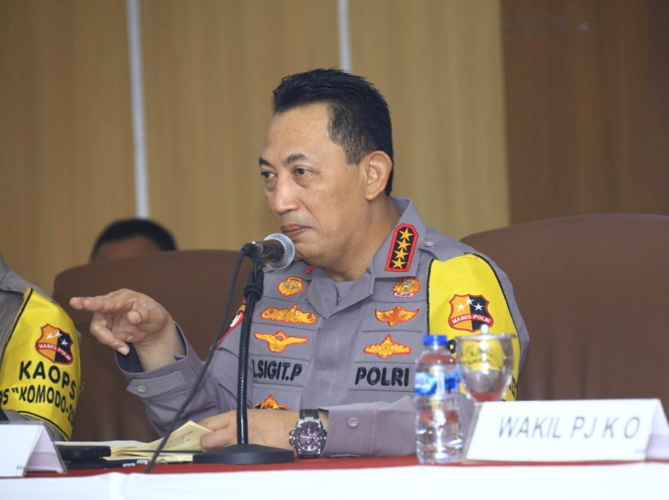

National Police Chief, General Listyo Sigit Prabowo, asserts that the National Military and National Police is solid in securing the 42nd ASEAN Summit 2023 (Photo: doc. PR Division of National Police)